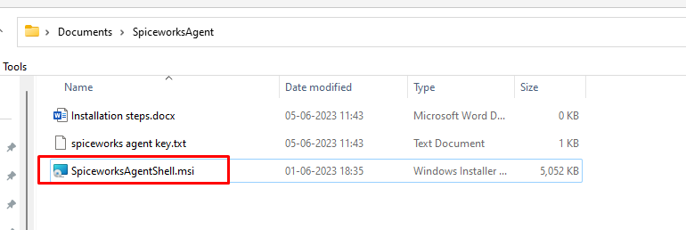

ntQtCSMQW4K9rrlptRsc

DONE.